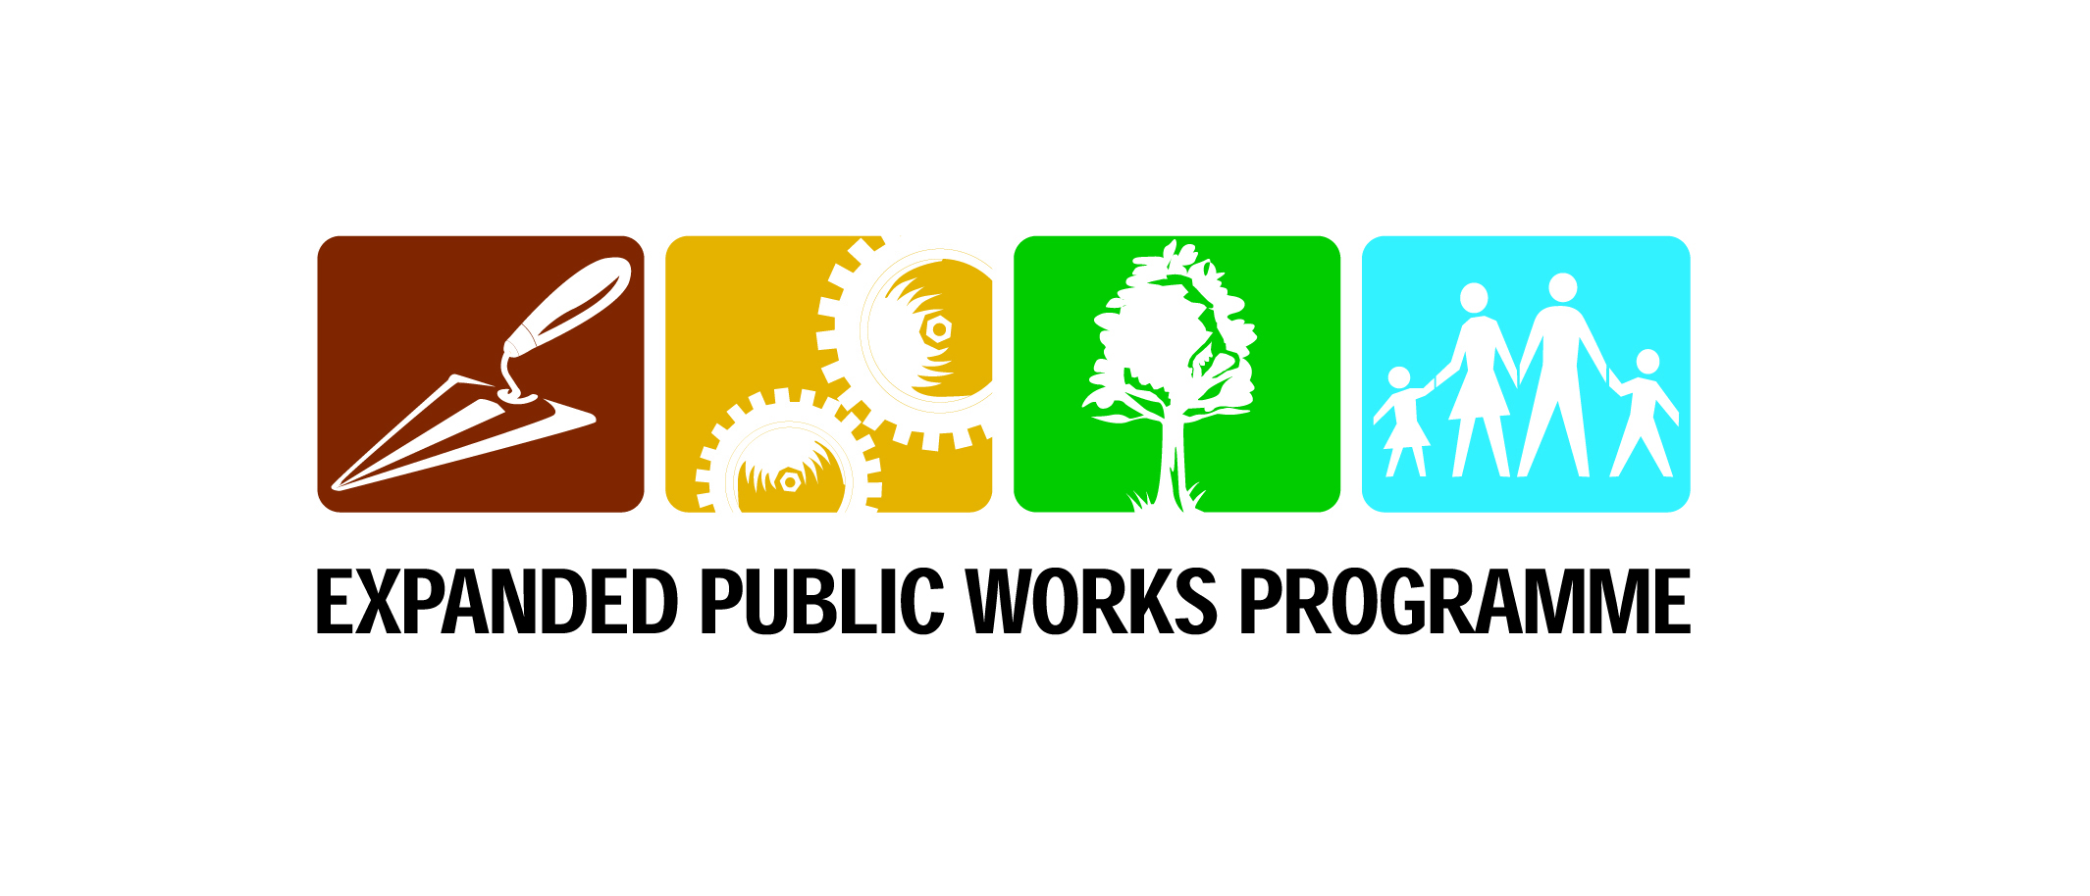
OUTLINE OF THE NYS EPWP ORIENTATION PROGRAMME
FOR YOUNG PEOPLE

Day 1 | What is National Youth Service? Trainers  Introductions, Expectations and Objectives of the Orientation Programme  Icebreaker/Getting to know each other  Activity 1: Developing Ground Rules  Activity 2: Understanding the Situation of Youth in SA  Activity 3: Understanding National Youth Service (overview)
Day 2 | Nature of the Particular NYS EPWP Project EPWP and Trainers  Activity 1: Overview of EPWP  Activity 2: Nature of the Service Activities  Activity 3: What Training will be Provided  Activity 4: Relevant Exit Opportunities  Activity 5: How this NYS EPWP Project will be Structured  Activity 6: The Conditions of Service in the NYS EPWP Project  Activity 7: Cost Analysis of a NYS Project
Day 3 | Active Citizenship Trainers  Icebreaker/Getting to know each other  Activity 1: What is a Democracy?  Activity 2: What is Citizenship?  Activity 3: Becoming an Active Citizen  Activity 4: Reflection – A Roadmap to Democracy
Day 4 | Using a Financial Institution-Banking Trainers and Bank Representative  Activity 1: Why Have a Bank Account?  Activity 2: Which Bank Services Do I Need?  Activity 3: Savings and Earning Interest  Activity 4: Bank Fees  Activity 5: Bank Presentation  Activity 6: Choosing a Transaction Account  Activity 7: Opening a Bank Account and Using an ATM
Day 5 | Youth Development Paradigm (the values, beliefs and attitudes that inform the NYS Programme) Trainers  Icebreaker/Getting to know each other  Activity 1: Reflection – Participants Expectations (and Reality Check)  Activity 2: How Young People are Often Perceived  Activity 3: How We Want Young People to be perceived  Activity 4: Reflection – My Own Perceptions
Day 6 | Knowing Self Trainers  Icebreaker/Getting to know each other  Activity 1: Where am I? – Relationship Maps  Activity 2: Is This Where I Want to be?  Activity 3: Where do I Want to go?  Activity 4: The Why and the How of Journaling  Activity 5: Journaling – A Reflection Exercise
Day 7 | Knowing the Sector – Preparing for the Site Visits Trainers  Icebreaker/Getting to know each other  Activity 1: Identifying a Mentor  Activity 2: Expectations and Perceptions of the Sector  Activity 3: Preparation for Site Visits
Day 8 | Knowing the Sector – Visiting the Sites EPWP and Trainers  Activity 1: Occupational Health and Safety  Activity 2: Site Visits  Activity 3: Making Sense of the Site Visits  Activity 4: Reflection
Day 9 | Personal Budgeting Trainers  Activity 1: The Stipend  Activity 2: Attitudes to Money  Activity 3: Personal Budgeting  Activity 4: Case Studies and Scenarios  Activity 5: Reflection
Day 10 | Making Decisions – Signing Contracts EPWP and Trainers  Activity 1: How Others See Me  Activity 2: An Honest and Realistic Reflection of Myself  Activity 3: Making a Commitment to My Decision  Activity 4: Signing Contracts, Completing Forms

LIFE SKILLS
ID | Unit Standard Title | NQF Level | Learning Subfield | Credits
114941 | Apply knowledge of HIV/AIDS to a specific business sector and a workplace | Level 3 | People/Human-Centred Development | 4
116966 | Apply knowledge of self and own situation to manage risks resulting from change in the workplace | Level 3 | People/Human-Centred Development | 3
11813 | Apply knowledge of self in order to make a life decision | Level 2 | People/Human-Centred Development | 3
114952 | Apply problem-solving techniques to make a decision or solve a problem in a real life context | Level 3 | People/Human-Centred Development | 2
114950 | Apply ways of leading in different situations | Level 2 | People/Human-Centred Development | 3
14659 | Demonstrate an understanding of factors that contribute towards healthy living | Level 1 | People/Human-Centred Development | 4
7503 | Demonstrate effective self-management skills | Level 1 | People/Human-Centred Development | 2
15093 | Demonstrate insight into democracy as a form of governance and its implications for a diverse society | Level 5 | People/Human-Centred Development | 5
11816 | Demonstrate knowledge and understanding of the rights and responsibilities of the individual under the South African Constitution | Level 2 | People/Human-Centred Development | 2
14661 | Demonstrate knowledge of self in order to understand one’s identity and role within the immediate community and South African society | Level 1 | People/Human-Centred Development | 3
7504 | Demonstrate skills that relate to a safe and secure environment | Level 1 | People/Human-Centred Development | 2
7498 | Describe health care practices and the consequences of chemical dependency | Level 1 | People/Human-Centred Development | 2
114947 | Design ways in which individuals in a community can contribute towards creating a caring environment for people who are vulnerable | Level 3 | People/Human-Centred Development | 3
7502 | Discuss and explain social diversity, human rights and alternative perspectives | Level 1 | People/Human-Centred Development | 2
114937 | Explain and apply ways of contributing towards community development | Level 3 | People/Human-Centred Development | 5
114949 | Identify oneself in a situation of abuse and develop coping mechanisms | Level 2 | People/Human-Centred Development | 2
114945 | Identify ways of managing relationships in own life | Level 2 | People/Human-Centred Development | 2

